



**4th Q Newsletter October - December, 2020**

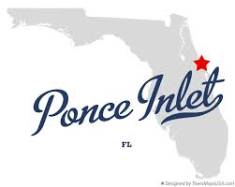 Hello to Southpoint Owners,

We hope this message finds you and your family safe and well.

Happy Thanksgiving!



Our SPC Annual Meeting is right around the corner. By now you have received the first and second meeting notices. **If you are not planning to attend the meeting personally, please be sure to send in your voting proxy before the meeting on Saturday, December 5th. Simply indicate who you are appointing your proxy to (fellow owner), sign and return or FAX to the office as indicated on the forms. It’s very important for us to have enough owners/proxy to meet the number to have a quorum.**

Per Roger Koop, the following improvements have recently been made at Southpoint –

1. Phase 1, or the South side of the building, now has new windows, walkways have also been resurfaced. Phase 2, the North side has begun window replacement!
2. The rest of the building renovations are almost complete.
3. Roger continues to post weekly engineering reports for your viewing pleasure on the Southpoint website under the Documents tab. You will also see photographs of the progress being made.

Have you visited any of our local places lately?

Try a visit to The Ponce Preserve.

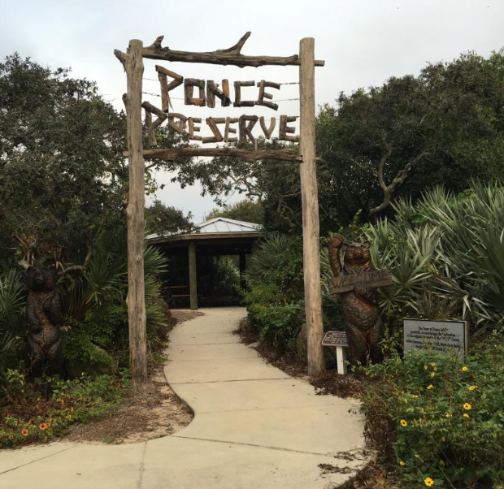

The Ponce Preserve is the town's largest park with approximately 41 acres stretching from the Atlantic Ocean to the Halifax River. Sitting at the heart of this park is the Green Mound State Archaeological Site, an ancient Indian midden. The terrain is varied, from the ocean dunes, through terraced palmetto patches and maritime hammock to the wetlands adjacent to the Halifax River. You'll find many of our native plants in the Preserve including Florida lantana, southern red cedar, cabbage palms, Simpson's stoppers and oak trees.

At the base of the Green Mound is a live oak estimated to be more than 350 years old.

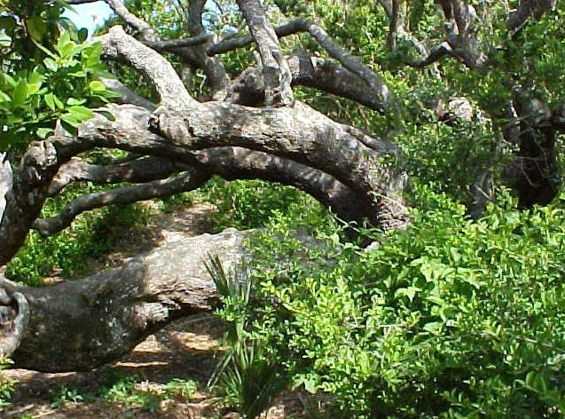

The Preserve has been added to the East Section of the Great Florida Birding Trail and is an excellent site for bird watching. The parking lot and restrooms on the east side of Peninsula Drive give direct access to the nature trails through the park. The boardwalk begins directly across the street and offers two places to launch canoes and kayaks while meandering one-third of a mile across the marsh out to the Halifax River. Three covered gazebos offer visitors a place to relax and enjoy unspoiled views.

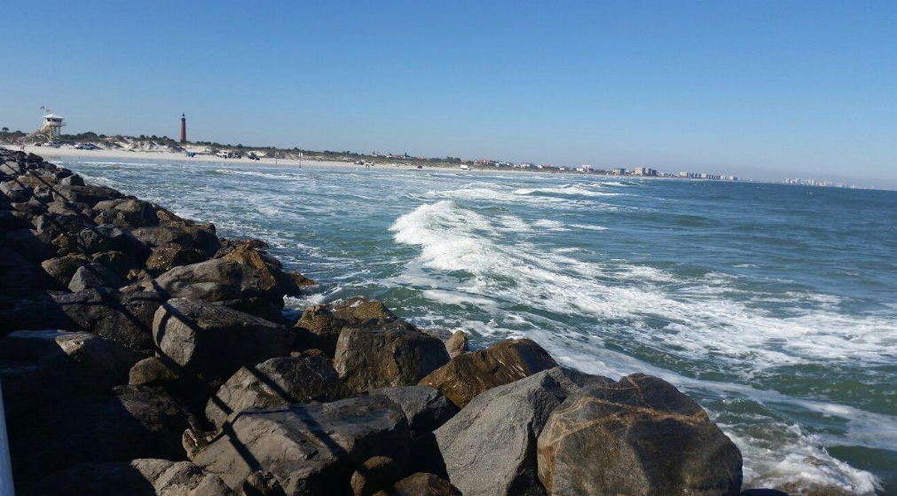

The Garden Club of Ponce Inlet provided the benches throughout the park and landscaping at the entrance island.

The center portion of the Preserve is home to two nature themed playgrounds, one located near the parking lot and one a short walk along a new trail at the center of the park adjacent to the wildlife observation tower.

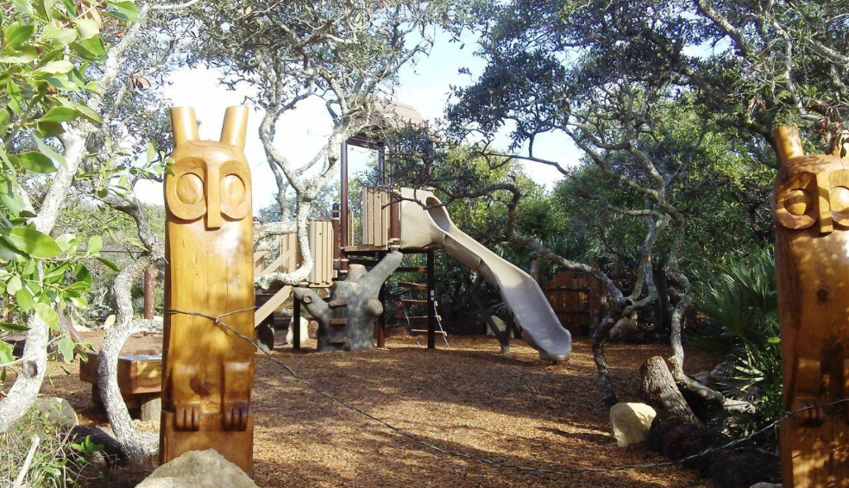

A covered picnic pavilion is located near the parking lot and playground and fitness stations are located along the trails. On the east side of Atlantic Avenue, a handicapped accessible dune walkover provide access to the pristine beach. There is also a small parking area with handicapped parking available.

**Address to Ponce Reserve:**4400 Block of South Atlantic and South Peninsula Drive, Ponce Inlet, FL

Share your pictures of your visit to the Ponce Reserve with us on our SPC Owners Facebook page, we’d love to see them!



Please remember that SPC is still an active construction zone. Currently the North side of the building is now under construction and is considered closed, except for contractors. If you must be in your unit (for updating), please use extreme caution. Renters are not at all allowed in the closed sections of the building and children are *never* allowed in an active construction site. No exceptions.

We wish you all a very Merry Christmas, Happy Hanukkah, and Happy Holiday to you and your family.

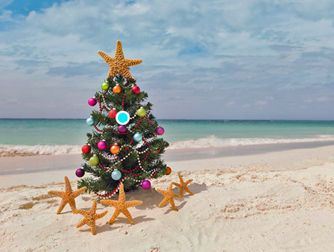





Owner Kevin Bailey has

created an e-mail list with owners names, unit #, e-mail address, telephone number and rental agency if you rent. If you’d like to be added to this list, please contact Kevin with your information at [kevinbail@bellsouth.net](mailto:kevinbail@bellsouth.net) and he’ll add you.

Lastly, Happy New Year to you all!

Let’s hope that 2021 will bring an end to the craziness of 2020 and a year filled with much happiness, great health to all, and fun times at the beach!





If you have any newsworthy information you’d like to see here, pictures, etc., please share it with us. You may send any information to Linda Collette via e-mail to: [redcar@charter.net](mailto:redcar@charter.net), and please put “SPC Newsletter” in the subject line. Thank you!

**Southpoint Condominium Association Board of Directors 2020**

**:**

Phil Danley, President - [phil.danley@gmail.com](http://mailto:phil.danley@gmail.com/)

Alan Powell, Vice-President - [adp5721@comcast.net](http://mailto:adp5721@comcast.net/)  
Judy Voiers, Secretary/Treas.  [jvoiers@tampabay.rr.com](http://mailto:jvoiers@tampabay.rr.com/)

Management Company: TJW Management Co, Inc.

Roger Koop, Manager and Maintenance Supervisor, 386-788-4546--[roger.koop@gmail.com](mailto:roger.koop@gmail.com) Karen Stewart - General Manager- kstewart@tjw.net